

**Awns’s Store**

**Final Release Document**

**Team 1**

– Hanoi, March 2023 –

**Table of Contents**

I. Deliverable Package 3

II. Installation Guides 3

# I. Deliverable Package

| **No.** | **File** | **Notes** |
| --- | --- | --- |
| 1 | SQLQuery1.sql | Database data |
| 2 | SWP_DB | Database structure |
| 3 | SDS Document.docx | Final SDS (Design) Document |
| 4 | SRS Document.docx | Final SRS (Requirement) Document |
| 5 | Issues Report.xlsx | Final issues tracking list of the whole project |
| 6 | Project Tracking.xlsx | Final project tracking list of the whole project |
| 7 | Others | Source code of project |

Other related deliverables:

* Tagged source codes:

<https://github.com/VuHwangg/SWP391-SalesWebsiteProject>

# II. Installation Guides

Step 1: Access link: <https://github.com/VuHwangg/SWP391-SalesWebsiteProject>

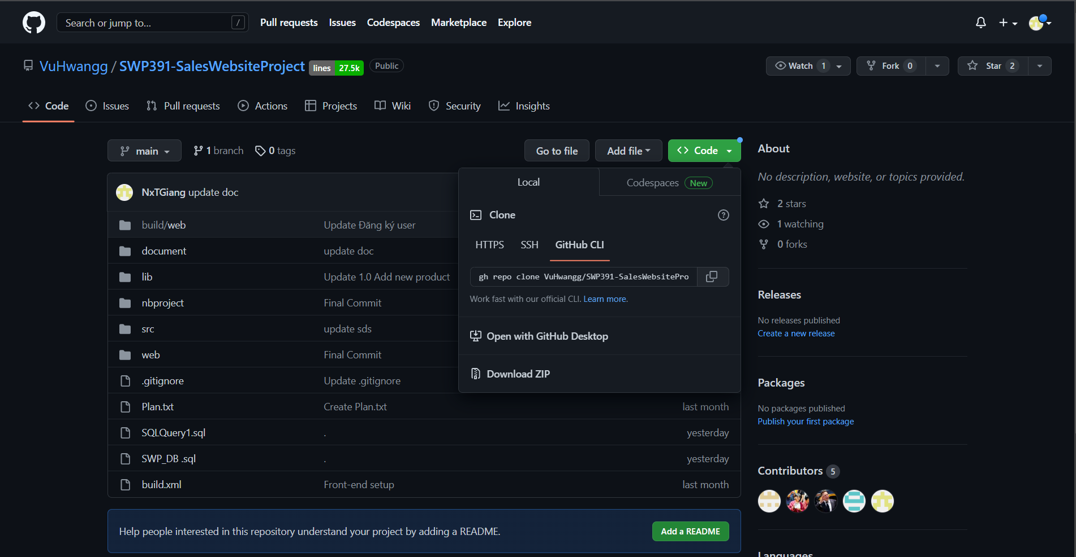

Step 2: Click on “<> Code” button, then click on “Download ZIP” to download zip file of project and extract zip file

Step 3: Open Netbeans and open project

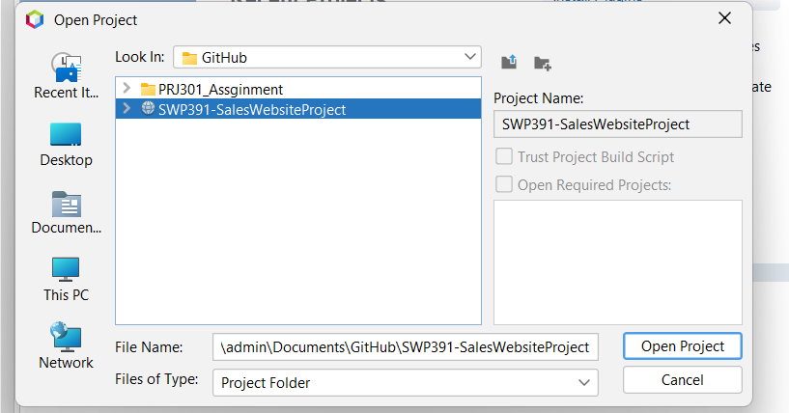

Step 4: Right-click on project, then click on “Run” button

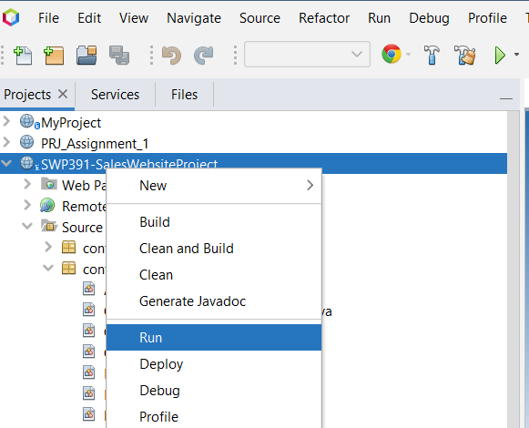

Step 5: Web browser was open and display screen: